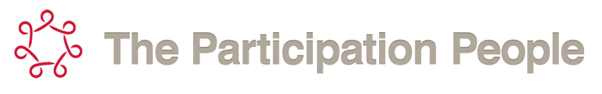
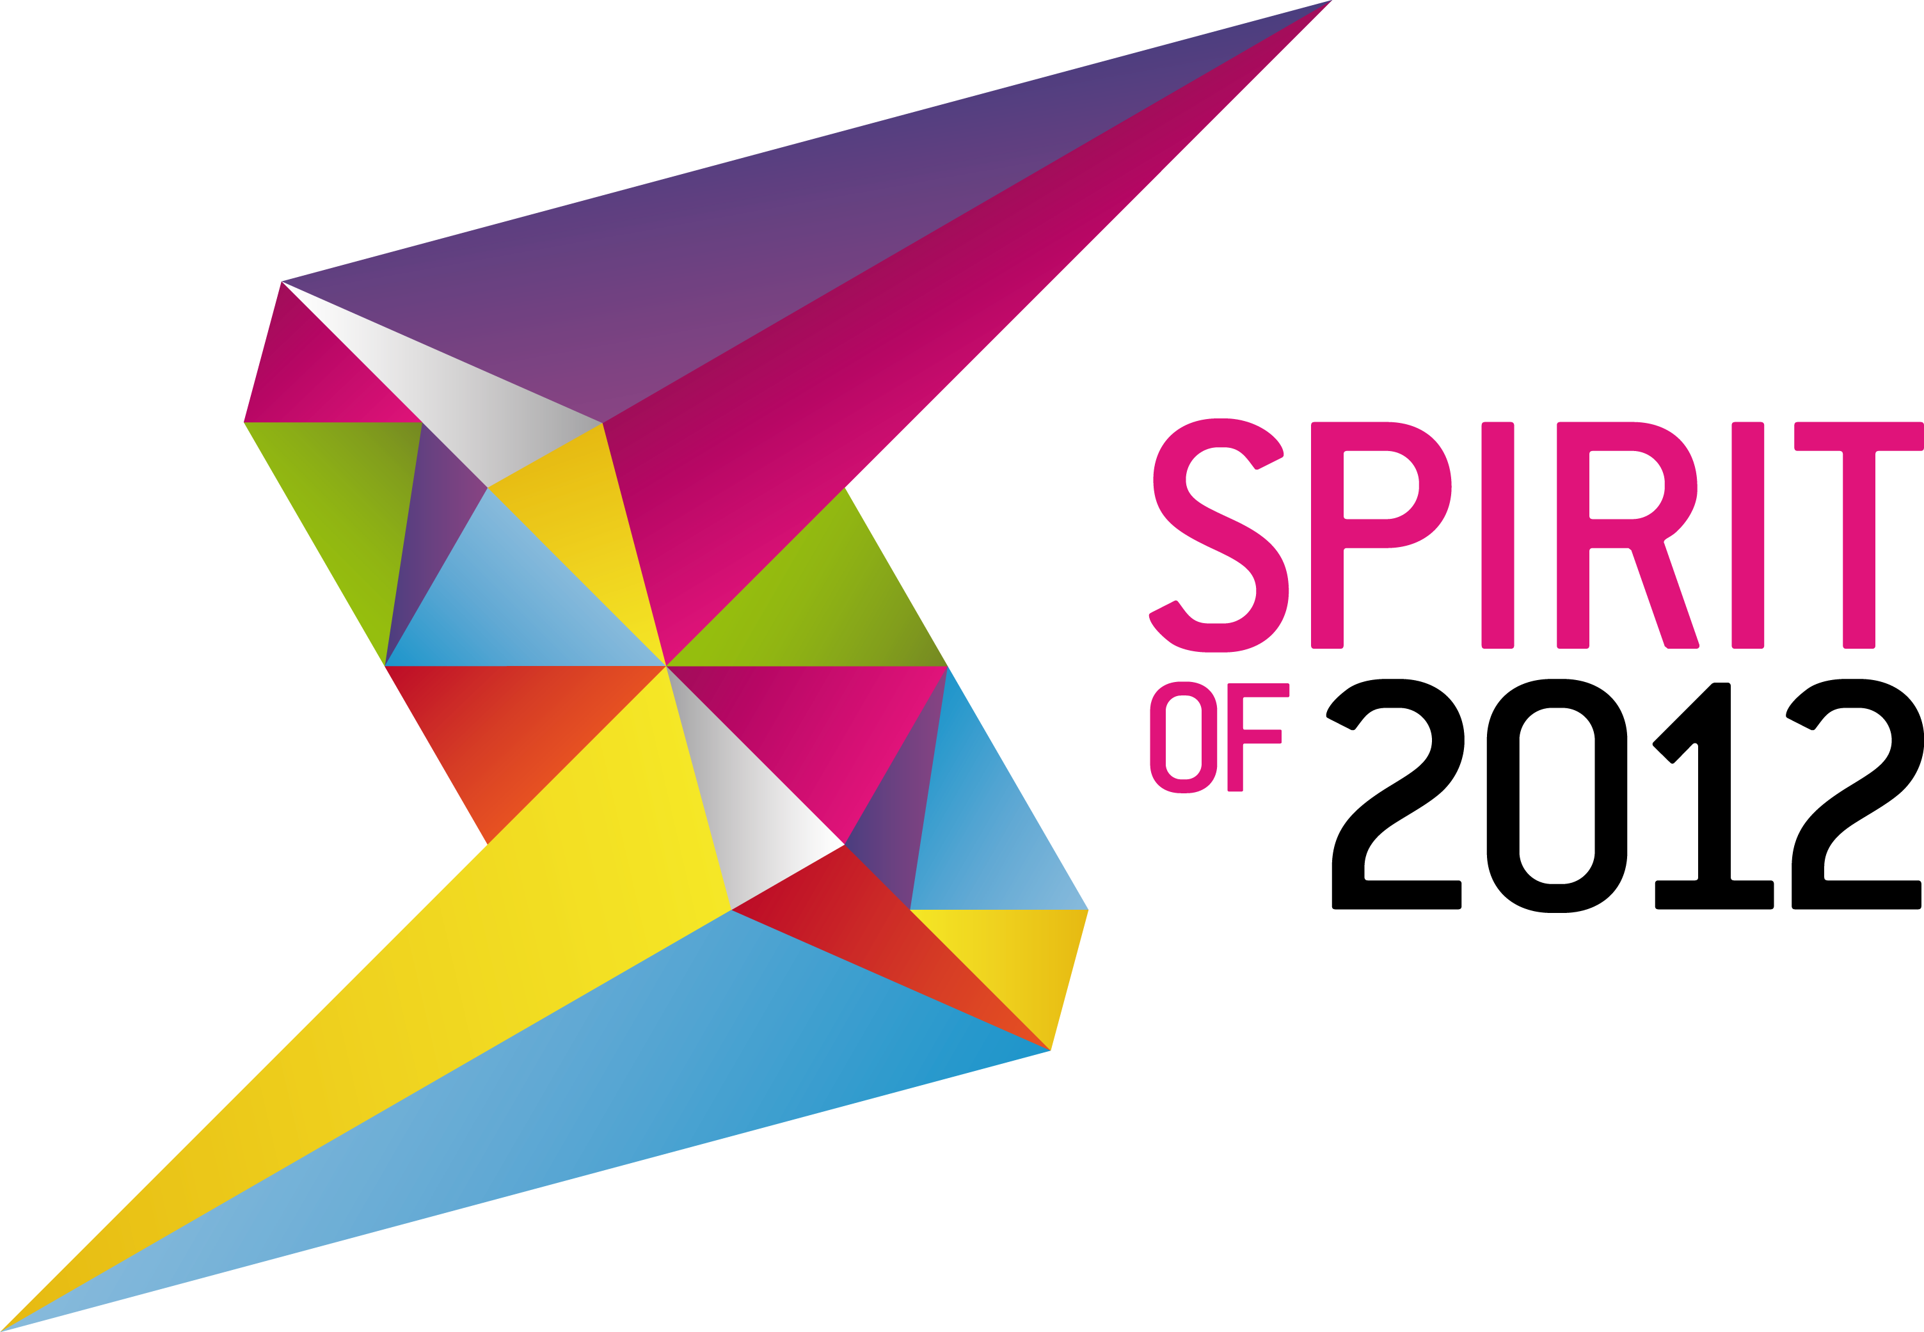

Youth Advisory Panel
Application Form

Think you can…

Be a champion for Spirit of 2012?

Advise Spirit of 2012 on its funding decisions?

Promote sports, arts, cultural and volunteering opportunities to other young people?

If so, you could be a member of the …
Spirit of 2012 Youth Advisory Panel!

February 2010

Welcome

Spirit of 2012’s Youth Advisory Panel will be made up of young people, aged 18-30, who are interested in developing themselves and the mission of Spirit of 2012.

Members of the Youth Advisory Panel will have two years in post. Their main role will be to act as champions for and advisers to Spirit. They will attend regular meetings, have access to training, mentoring and self-development opportunities, but most of all have a lot of fun!

The panel will have the opportunity to help guide Spirit’s grant giving decisions, and to visit and report back on Spirit-funded projects that promote opportunities across community sport, culture and the arts, education and volunteering.

Spirit is delighted to be working with The Participation People to facilitate the Youth Advisory Panel. The Participation People is a specialist youth engagement agency whose mission is to empower young people to inform and influence decision-making, producing positive change in communities.

A FANTASTIC opportunity!

A bit about Spirit of 2012

Spirit of 2012 is an independent grant-giving charity established by the Big Lottery Fund to ensure that the spirit which radiated from the London 2012 Olympics and Paralympics is felt by everyone, everywhere. By connecting events to communities across the country, we ensure our investment is of local, regional and national benefit. We tackle isolation and disadvantage by supporting those providing opportunities in sports, the arts and volunteering.

Our vision is to empower people to get out, be involved and feel better.

We support projects that further our four key aims:

- Harness the energy, commitment and organisation of the volunteering legacy of London 2012 for community benefit.

- Build on the energy, creativity and positive spirit inspired by the London 2012 Games to galvanize and inspire groups of people into social action.

- Use local and national events as a catalyst for creating partnerships, which will develop community activities and wider social action initiatives in order to encourage full and active participation from all community members.

- Enhance the post-London 2012 Paralympics understanding of the issues facing disabled people in order to achieve a step-change in positive attitudes to disability and impairment.

What’s in it for you?

There are too many opportunities to mention, but here are a few:

- Loads of fun!
- Leadership opportunities
- ASDAN accreditation
- Professional mentoring
- Advising Spirit on its funding decisions
- Acting as a champion for the Youth Advisory Panel and Spirit of 2012
- Networking with senior decision makers
- Meeting new people
- Gaining insight into grant decision making processes
- Tailored training and self-development coaching
- A detailed reference for college, university or employment
- The opportunity to have your voice heard and listened to at a senior level
- Making a real difference and creating positive change

Tailored skill development in:

- Leadership
- Communications
- Decision making
- Problem solving
- Grant giving
- Grant monitoring
- Networking
- Influencing
- Charity governance
- Team work
- Self-reflection

What’s in it for us?

- Creating youth champions and future leaders from across the UK
- Listening to youth voices and perspectives
- Ensuring that young people are key stakeholders in Spirit’s work
- Helping us build our networks
- Ensuring that our work is beneficial to young people across the UK

Interested?

If so, please fill out pages 6-12 of this form by 12pm Sunday 4 January 2015 and email to info@participationpeople.com or post to: Unit 7, 15 Highfield Close, London, SE13 6UY.

We are looking for young people with a range of skills to take part. To show off your skills when answering the questions on page 7 of this application form, please feel free to:

- Write your answers on the form
- Write your answers on the form and provide illustrations to support your answers
- Film your answers
- Record a voice note of your answers

Any of these application methods would be very welcome.

If you would like to fill in this application online, here is the link: https://www.surveymonkey.com/s/So2012_YAP2015-17

If you need a bit of extra help and or want some hints and tips with your application, we would love to support you.

We are running two application support sessions on the following dates:

- Wednesday 10th December 2014, 6pm – 8pm

- Monday 29th December 2014, 8pm – 10pm

There are two ways you can join in:

- Skype – add ParticipationPeople to your contacts and Instant Message us.

- Conference call in with this number 0330 606 0182 and use the pin code 491442#

Questions?

Contact us any time and we would love to answer your questions:

 info@participationpeople.com  07921 907210

❖ Participation People, Unit 7, 15 Highfield Close, London. SE13 6UY.

Spirit of 2012

Youth Advisory Panel

Application Form

First name:

Surname:

Gender: Male/Female

Date of birth: (please note that you must be aged between 18 and 30 for the duration of your membership of the Youth Advisory Panel – i.e. from 23rd Jan 2015 until 23rd Jan 2017)

Address:

Postcode:

Home phone number:

Mobile number:

Email:

Skype username (if you have one):

Twitter username (if you have one):

Are you currently a member of any of the following groups? (Please tick all that apply)

Voluntary group Community group

Uniformed group Student union

What is the name of the group you attend?

Do you attend another group not listed above? If so, please write it here:

Are you at College/ University? If so, which one, and what are you studying?

Have you been involved in anything like a youth advisory panel before? If so, please tell us about it:

We’re looking for someone who…

- Is committed, lively and outgoing
- Is prepared to volunteer 2 hours a week
- Has an interest in issues affecting young people
- Is able to listen to and respect the views of other people
- Takes their responsibilities seriously
- Is not afraid to speak their mind
- Asks for support, advice and help if needed
- Wants to develop their skills
- Has a sense of humour
- Can work as part of a team

When answering the following questions, think about what we are looking for, the aims of Spirit of 2012 and try to include this in your answers…

Q1. Why do I want to be a Youth Advisory Panel Member? (Word limit 100 words)

Q2. What skills and qualities would I bring to the role? (Word limit 100 words)

Q3. What do I want to achieve for young people across the UK? (Word limit 100 words)

I am available for the following dates and times (please tick):

- A Phone/ Skype/ FaceTime 30 minute interview – Sunday 11th January 1pm – 4pm; Monday 12th January 4pm – 6.30pm or Tuesday 13th January 4pm – 6.30pm

- Training Residential – 23, 24 and 25 January 2015 (London)

- Youth Advisory Panel Meeting 1 – 12 February 2015, 4pm – 6pm (online)

- Youth Advisory Panel Meeting 2 – 21/22 March 2015 (Location TBC)

- Youth Advisory Panel Meeting 3 – 4/5 July 2015 (Location TBC)

- Youth Advisory Panel Meeting 4 – 3/4 October 2015 (Location TBC)

You will be partnered with a professional mentor from a pool of experienced Spirit staff and board of trustee members who have a wide range of skills and expertise. You will have 60-minute virtual meetings with them every other month. They will support your skill development and progression.

You will also have weekly 30-minute coaching calls with specialist staff from the Participation People - Antonia Dixey or Josh Harsant. They will support your involvement in the panel. We will schedule these calls at the training residential.

All of your travel and accommodation costs will be covered.

Next steps
We will acknowledge receipt of your application via text message or email.

By 5pm Friday 9th January 2015, we will let you know if you have been successful or unsuccessful at the shortlisting stage.

If you have been unsuccessful, we will give you detailed feedback on your application. We will also point you in the direction of other fantastic volunteering opportunities.

If you are successful, we will invite you to take part in a phone/ Skype/ FaceTime interview.

Please tick three options which work best for your interview date and time:

Tick | Sun 11th Jan | Tick | Mon 12th Jan | Tick | Tues 13th Jan | Tick | Wed 14th Jan
 | 13:00 – 13:30 |  | 14:00 – 14:30 |  | 16:00 – 16:30 |  | 14:00 – 14:30
 | 13:40 – 14:10 |  | 14:40 – 15:10 |  | 16:40 – 17:10 |  | 14:40 – 15:10
 | 14:20 – 14:50 |  | 15:20 – 15:50 |  | 17:20 – 17:50 |  | 15:20 – 15:50
 | 15:00 – 15:30 |  | 16:00 – 16:30 |  | 18:00 – 18:30 |  | 16:00 – 16:30
 | 15:40 – 16:10 |  | 16:40 – 17:10 |  | 18:40 – 19:10 |  | 16:40 – 17:10
 |  |  | 17:20 – 17:50 |  | 19:20 – 19:50 |  | 17:20 – 17:50
 |  |  |  |  |  |  | 18:00 – 18:30
 |  |  |  |  |  |  | 18:40 – 19:10
 |  |  |  |  |  |  | 19:20 – 19:50

Don’t forget to submit this form by 12pm Sunday 4 January 2015!

Your signature:

Signed:
Print:
Date:

Endorsements

When thinking about who might be best to endorse your application, think about:

- Your question answers
- Who you have worked with/ volunteered with in the past
- Who knows you best
- What the Youth Advisory Panel is all about

Names and signatures of two people endorsing your application:

Person 1:

Why are you endorsing this person to be a Youth Advisory Panel member? (word count 30 words)

Signed:
Print name:
Date:

Person 2:

Why are you endorsing this person to be a Youth Advisory Panel member? (word count 30 words)

Signed:
Print name:
Date:

Equal opportunities

We need to gather this information to monitor the extent to which this recruitment opportunity reaches as many groups of young people as possible. Completing this section will help us to do this. The sole purpose of this information will be for monitoring, and will not affect your application in any way. You do not need to complete this form if you do not want to.

The information which you provide on this part of the application form will be kept anonymously in accordance with the Data Protection Act 1998.

Please tick circle all that apply:

Ethnicity – are you?

White | English/Scottish/Welsh/Northern Irish/UK
White | Irish
White | Gypsy/Irish Traveller
White | Any other White Background
Mixed ethnic background | Mixed ethnic background
Asian/Asian UK | Indian
Asian/Asian UK | Pakistani
Asian/Asian UK | Bangladeshi
Asian/Asian UK | Chinese
Asian/Asian UK | Any other Asian background
Black/African/Caribbean/Black UK | African
Black/African/Caribbean/Black UK | Caribbean
Black/African/Caribbean/Black UK | Any other Black /African/Caribbean background
Other ethnic group | Arab
Other ethnic group | Any other ethnic group

Disability – are you…?

Under the Disability Discrimination Act 1995 (DDA) a person is considered to have a disability if he/she has a physical or mental impairment which has a sustained and long-term adverse effect on his/her ability to carry out normal day to day activities. Since 2005, people with HIV, cancer and multiple sclerosis (MS) are covered by the DDA.
Please state the type of disability that applies to you. People may experience more than one type of disability, in which case you may indicate more than one. If none of the categories apply, please mark ‘Other’ and specify the type of disability.
Physical impairment, such as difficulty using your arms or mobility issues which means using a wheelchair or crutches
Sensory impairment, such as being blind / having a serious visual impairment or being deaf / having a serious hearing
Mental health condition, such as depression or schizophrenia
Learning disability/difficulty, (such as Down’s syndrome or dyslexia) or cognitive impairment (such as autistic spectrum disorder)
Long-standing illness or health condition such as cancer, HIV, diabetes, chronic heart disease, or epilepsy
Other (please specify):

Are from the any of the following under-represented groups?
Looked-after or are a care-leaver
A carer
Refugee or seeking asylum
From a traveller community
Young parent
Not in education, employment or training
From a low income background
Homeless or sleeping rough

Role description

Youth Advisory Panel Member

Spirit of 2012’s Youth Advisory Panel will be made up of young people, aged 18-30, who are interested in developing themselves and the mission of Spirit of 2012.

Members of the Youth Advisory Panel will have two years in post. Their main role will be to act as champions for and advisers to Spirit. They will attend regular meetings, have access to training, mentoring and self-development opportunities, but most of all have a lot of fun!

The panel will have the opportunity to help guide Spirit’s grant giving decisions, and to visit and report back on Spirit-funded projects that promote opportunities across community sport, culture and the arts, education and volunteering.

What is the purpose of the Youth Advisory Panel?
The Youth Advisory Panel is a group of young champions for Spirit of 2012 who will use their experience and passion to guide and inform on issues relevant to young people in the UK.

The panel will support Spirit to make informed grant decisions. They will also be responsible for building up Spirit’s youth networks and ensuring that young people have a say in Spirit’s governance structures.

Spirit wants young people to be a key player in relevant decisions; the Youth Advisory Panel will support them to do that.

At the end of my two years I will have…
- Received training in a number of new skill areas
- Received an ASDAN accreditation
- Developed a strong network
- Had over 100 coaching calls
- Had over 45 hours of professional mentoring
- Helped Spirit make informed funding decisions
- Represented Spirit to different networks across the UK

Youth Advisory Panel membership
In order to ensure a strong, creative and empowered Youth Advisory Panel, we want to ensure that it is representative of the youth population across the United Kingdom. Members are recruited through open applications, targeted recruitment and through partners.

What help can I expect?
- Training
- Tailored personal development
- A professional mentor
- Volunteer expenses paid e.g. travel and food
- A reference for employers, college and university

