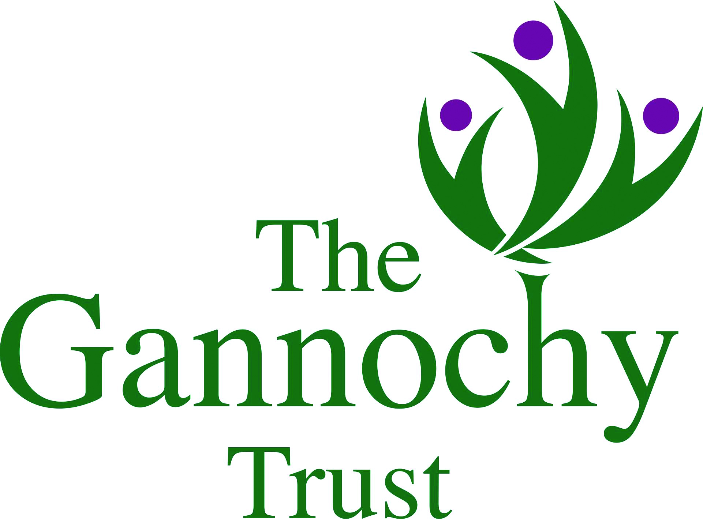   | Living Communities Participation Fund  Application Form

Contact Information
Contact Name:

Contact Address:

Street Address

 | City |  | Post Code

Phone: |  | Email:

Project Information
Project Title:
Project Start Date: |  |  |  | Project End Date:
Participant age range: |  |  |  | # of Pupils participating:
Participating school(s):
Please describe the proposed project. (Max 200 words)
Please tell us how this project meets the identified learning objectives for pupils. (Max 200 words)
Please provide an outline project plan below, indicating start and end dates for the project, key milestones and tasks:
KEY MILESTONE/TASK |  |  |  |  |  |  |  | TIMESCALE
Preference will be given to applications which can demonstrate that they support some or all of the following criteria:
- Benefits for marginalised or vulnerable children and young people and/or addresses inequalities
- Intergenerational projects
- An exploration of local heritage and culture at the heart of the project
- Strengthened school/community partnerships

Please explain which of these criteria your project supports and how (max 300 words):

Please identify any key partners/groups/external workers that you anticipate working with on the project.
Please complete the project budget below.
Please include all anticipated project costs, including in kind contributions. Where exact requirements cannot be determined prior to the project commencing please tell us how you have arrived at the estimated costs in the field “Notes”. VAT which you cannot reclaim is listed separately in the VAT column. VAT should not be included if you can reclaim it.

Might be useful to ask applicants to indicate if they intend to apply elsewhere for additional funds to deliver the project as some of the projects may have a larger project total than the grant amount.

ITEM |  |  | NOTES |  | SUPPLIER |  |  |  | COST £ |  | VAT £
 |  |  |  |  | TOTAL |  |  |  | £0.00 |  | £0.00
 |  |  |  |  |  |  |  |  | GRAND TOTAL |  | £0.00

Information for Applicants

Any single school in Perth and Kinross can apply for a grant of up to £1,200 for project costs. Where two or more schools wish to work together a maximum grant of £5,000 can be applied for.

There will be two rounds of funding in the 2016/17 academic year. The deadline for initial projects is Friday 16 September, with the funding decisions made by 30 September. The deadline for the second round of applications will be Friday 9 December, with funding decisions made by 23 December.

Initial enquiries should be made to the Heritage Learning Officer, Rebecca Berger (RBerger@culturepk.org.uk | 01738 477037). Once a project idea is in place, the HLO will meet with participating schools to advise on the project plan and application.

HLO Use Only
Date application received: |  | SMT decision:
 |  | Date school informed:

