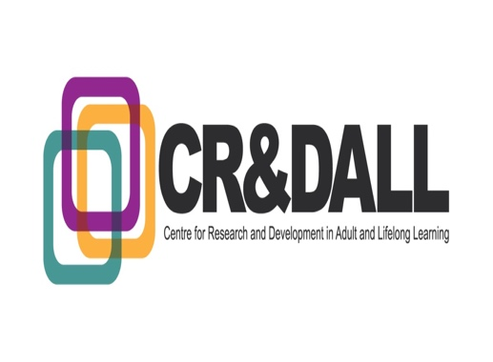

Seminar Series 2017-18

Ageism in intergenerational learning activities

Dr. Tiina Tambaum, University of Tallinn

Tuesday, February 20th, 2018, 12.30-14.00, Room tba, School of Education, St. Andrews Building, 11 Eldon Street, University of Glasgow, Glasgow, G3 6NH

Ageism towards older people is a relatively unresearched topic. The same applies to intergenerational learning and issues related to the inclusion of older men. It therefore is interesting to bring all these three components onto one table. The first results of our survey in Estonia about older rural men’s readiness and obstacles to passing on their skills and knowledge indicated limited use of older men’s potential (Tambaum & Kuusk, 2014). This finding, when considered in the light of the fact that the opportunity to be a provider rather a recipient of learning represents the key characteristic for intergenerational learning (FIM-NewLearning, 2008), offers a reason to explore the possible implications of ageism in intergenerational learning activities. Data from ongoing Erasmus+ project "Old men say yes to the community", theories of intergenerational learning and knowledge gained from a COST network on Ageism form the base of our planned work.

References
FIM-NewLearning. (2008). EAGLE Final Report, Intergenerational Learning in Europe: Policies, Programmes & Practical Guidance, Retrieved from http://www.menon

Tambaum, T. & Kuusk, H. (2014). Passing on skills and knowledge as part of learning for older men – readiness and obstacles among older men in the municipality of Tartu. In Radovan, M.; Jelenc Krašovec, S. (eds). Older Men Learning in the Community: European Snapshots, Ljubljana: Ljubljana University Press, 29–48.

Presenter: Tiina Tambaum is a Research Fellow at the Estonian Institute for Population Studies, Tallinn University and she teaches Educational Gerontology classes for postgraduate students at the Institute of Educational Sciences. Tiina has postgraduate degrees in Mathematics (1991), Educational Sciences (2001) and Business Administration (2004). During the last 5 years she has been engaged in SHARE project as a researcher and a project manager. In her doctoral research, she has been dealing with questions of tutoring skills in intergenerational learning circumstances in which teenage students instruct older people to use Internet. In 2015, she introduced her preliminary results also in Glasgow. She has published academic articles about older learners in mixed-age learning groups and about older rural men’s readiness and their obstacles to passing on their skills and knowledge. In 2016 the first Gerontology text book for HEIs in Estonian was published and two chapters were written by Tiina: “Educational Gerontology” and “Ageism”. Tiina is a co-founder of the Estonian NGO 65B. The aim of NGO is to share and develop professional knowledge for people who are facilitating older people development and activity in Estonia. The NGO runs the e-magazine Seinaleht (A Wall Paper) edited by Tiina (www.65b.ee).

In 2017, Tiina published a book in Estonian titled “Glasgow is better than Edinburgh”. This 121-pages hardcover book includes stories from periods Tiina spent in Glasgow in 2014–2015 and 2016 as a visiting researcher invited by University of Glasgow. The book is found through this link:
(https://www.rahvaraamat.ee/p/%C5%A1otimaa-glasgow-on-parem-kui-edinburgh/997554/et?isbn=9789949581283)

She is a visiting lecturer at the University of Glasgow as a contributor to the Erasmus Mundus funded International Masters in Adult Education for Social Change led from the University of Glasgow within which her university is a partner.

All are welcome. Please RSVP to cradall@gla.ac.uk to book your place. A sandwich lunch will be available at 1230.

