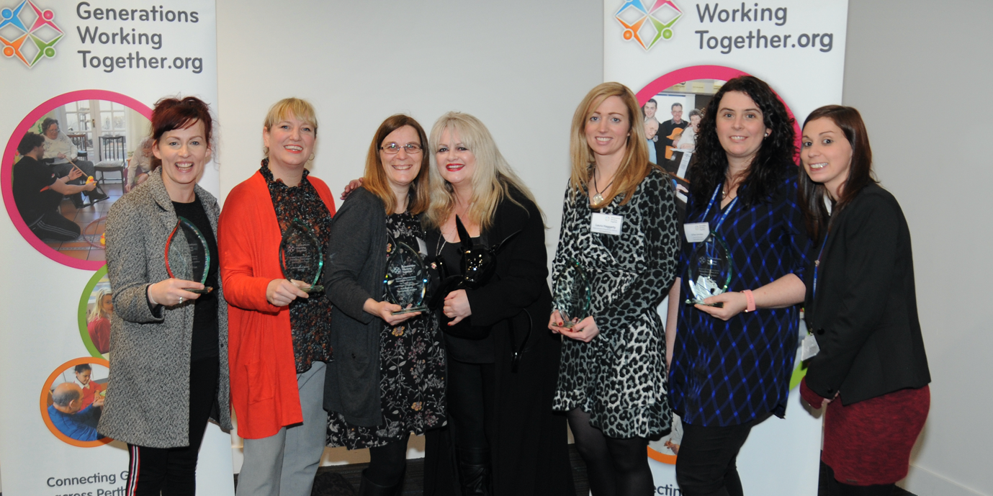
Awards 2020 - Nomination Form
Section 1
Project Name:
(to be used on the award and any related materials and publications).

Name, contact details and relationship to the nominee of the person submitting the application:

Referee and Contact Details:
(this should be someone with a good working knowledge of your project, who is willing to be contacted in relation to your application).
Section 2
Project Summary (max 150 words)
(a short summary of your project’s aims and main activities. This description will be used in materials and publications relating to the awards).

Project dates
When did your project begin? | Month: | Year:
When did your project finish? | Month: | Year:
Or is it still ongoing? | Yes: | No:

Which Award Category do you want to be considered for?
(a project can be considered under more than one category, providing it satisfies the relevant eligibility criteria). Please tick as appropriate).
- Most Innovative Project
- Most Improved Project
- Promoting Achievement and Attainment in Education
- Reducing Loneliness and Isolation

What are you trying to achieve through your project? (Max 200 words)
(here you should provide the main aims of the project and the outcomes that you are trying to achieve).
Section 3
Why did you decide to adopt an intergenerational approach to help you achieve your aims? (Max 150 words)

Most Innovative Project Only (Max 200 words)
What is it that makes your project different and innovative?

Most Improved Project Only (Max 250 words)
What was the need for change and improvement that you identified?
(Here we want you to tell us what needed to change about your project and how you identified that need).

Section 4
What does your project do? (Max 500 words)
(Here we are asking you to describe the main activities of your project. You should be sure to tell us who is involved as well as what activities and/or services you deliver. We would also like to hear about how you engage and involve participants in planning and delivery).

What difference is your project making and how do you know this? (Max 300 words)
(Here we are asking you to tell us about the impact of your project on participants and the wider community. We also want to know what information or evidence you have to confirm this.
If you are applying to be considered for the Most Improved Project Category, this is where you should tell us how you have improved and how you know this). Please refer to guidelines for notes on impact and evidence.

What plans do you have for sustaining your project and its impact over time? (Max 200 words)
(Here we want to find out about how you are planning for the future, both for the project and individual participants).
Section 5
Photos
Please include a maximum of THREE high resolution photographs with your nomination, which in some way capture the essence of the relationship and/or activity of the project. These pictures will be used as part of promotional material for the awards and may be included in subsequent GWT on and off-line publications.
Declaration
- I confirm that the project is happy for the contents of this application to be used by GWT in publications and online promotional activity.
- I confirm that the project is happy to be contacted for further information if necessary, for the administration of the Awards and/or to support future GWT awareness raising and promotional activity.
- I confirm that I have explained to all those appearing in the pictures that I have submitted that these images may appear in conference materials, GWT publications and online. If they are used, they will be anonymised
AND
that I have secured, and could provide on request, written confirmation of people’s consent to the submission and subsequent use of these photographs in the ways described above.

Name _________________________________________ Date __________

Please submit your nomination and high resolution photographs by Friday 7th February 2020 at 12noon to: bella@generationsworkingtogether.org

