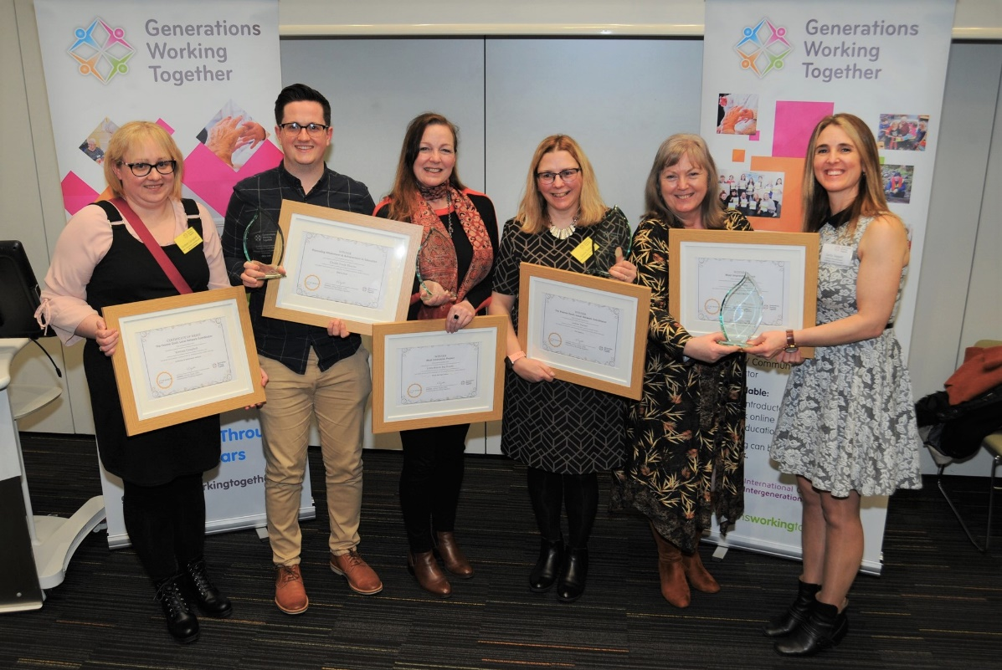

Awards 2021 – Nomination Form
Section 1
Project Name
To be used on the award and any related materials and publications

Name, contact details and relationship to the nominee of the person submitting the application

Referee and Contact Details
This should be someone with a good working knowledge of your project, who is willing to be contacted in relation to your application

Section 2
Project Summary (max 150 words)
A short summary of your project’s aims and main activities. This description will be used in materials and publications relating to the awards

Project dates
When did/will your project begin? | Month: | Year:
When did/will your project finish? | Month: | Year:
Or is it still ongoing? | Yes: | No:

Which award category do you want to be considered for?
A project can be considered under more than one category, providing it satisfies the relevant eligibility criteria. Please tick as appropriate.
- Innovation in the Community
- Digital Innovation
- Tackling Ageism
- Creative ways to connect after Covid-19

What are you trying to achieve through your project? (max 200 words)
You should provide the main aims of the project and outcomes that you are trying to achieve

Section 3
Why did you decide to adopt an intergenerational approach to help you achieve your aims? (max 150 words)

Awards 1 & 2 only (max 250 words)
What is it that makes your project creative?

Award 3 only – Tackling Ageism (max 250 words)
How was the need for your specific activities identified?
Here we want you to tell us what needed to change and how you identified that need.

Section 4
Project Summary – all awards (max 500 words)
Here we are asking you to describe the main activities of your project. You should be sure to tell us who is involved as well as what activities and/or services you deliver. We would also like to hear about how you engage and involve participants in planning and delivery.

What difference is your project making/will make and how do you know this? (max 300 words) Here we are asking you to tell us about the impact and potential impact of your project on participants and the wider community. We also want to know what information or evidence you have to confirm this.
Please refer to guidelines for notes on impact and evidence.

What plans do you have for sustaining your project and its impact over time?
(max 200 words)
Here we want to find out about how you are planning for the future, both for the project and individual participants.

Section 5
Photos
Please include a maximum of THREE high resolution photographs with your nomination. These photos should capture the essence of the relationship and/or activity of the project. These pictures will be used as part of promotional material for the awards and may be included in subsequent online and offline publications by Generations Working Together.
Declaration
- I confirm that the project is happy for the contents of this application to be used by GWT in publications and online promotional activity.
- I confirm that the project is happy to be contacted for further information if necessary, for the administration of the Awards and/or to support future GWT awareness raising and promotional activity.
- I confirm that I have explained to all those appearing in the pictures that I have submitted that these photographs may appear in conference materials, GWT publications and online. If they are used, they will be anonymised.
- I confirm that I have secured, and could provide on request, written confirmation of people’s consent to the submission and subsequent use of these photographs in the ways described above.

Name | Date

Please submit your nomination and high-resolution photographs by Friday 5th February 2021 at 12 noon to: bella@generationsworkingtogether.org

