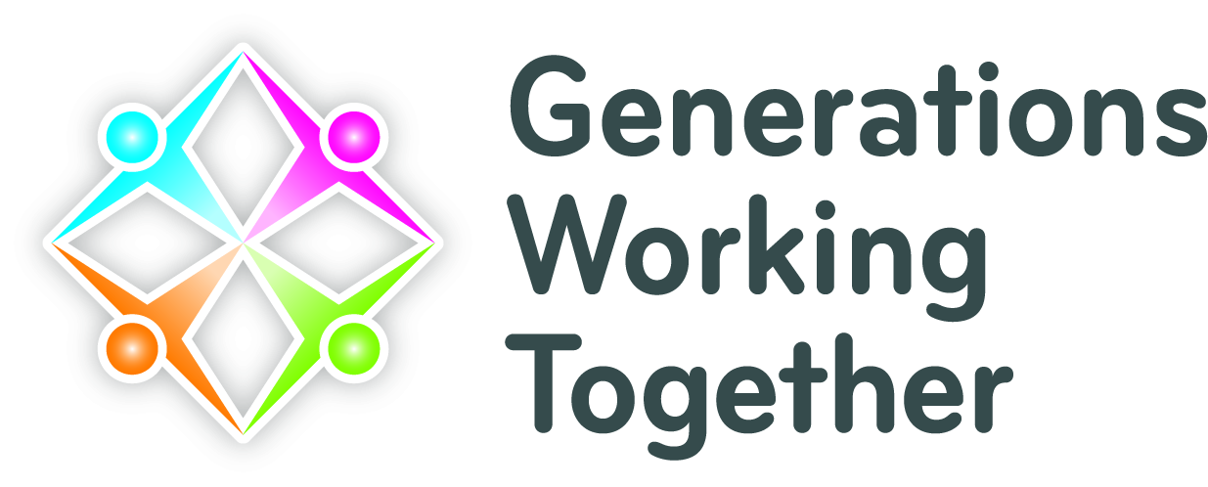
Network Meeting Forth Valley
Date: 27th September 2022
Venue: Forth Valley Sensory Centre, Camelon

In attendance: Linda Stewart (Carrondale Care Home); Susan Hill (Wellside Kindergarten Limited); Liz Rowlett (CTSI/SVE); Michael White (Screen Memories); Breda Seaman (Dunblane Development Trust); Carley O’Hare (Stirling Carers Centre); Diane Cherry (Clackmannanshire Council); Jamie Butcher (Raploch Community Partnership); Alyson Ross (Raploch Community Partnership), Anne Brown (HC One); Stephanie Faichney (HC One); Ross Crawford (GWT)
Apologies: Victoria McRae (CVS Falkirk); Carolyn Dick (Dates-n-Mates); John Ritchie (University of Stirling)

Local Update

Update from Michael White at Screen Memories

Michael updated the group on recent work from Screen Memories, a volunteer-led initiative aimed especially at older people living with dementia. The volunteer team visits care homes and other facilities and engages people through cinema and movie stars. Michael relayed a number of anecdotes of older people benefiting immediately from this form of social stimulation. Another project, Jukebox Days, accomplishes similar effects through the use of music. The team are implementing intergenerational aspects to their work, with school pupils invited to join sessions and get to know the older people by discussing how cinema and music has changed over the years. Several attendees around the room were keen to engage with Michael at their own workplaces.

Update from Breda Seaman, Dunblane Development Trust

Breda provided an update on how her work to make Dunblane more dementia friendly has progressed over the years, including the introduction of intergenerational aspects. Several attendees around the room were keen to find out more about Breda’s work and how they might collaborate.

Discussion Areas

- Discussion of how people, especially younger people, can be supported should an older person they are working with pass away. It was noted that the Anna Freud Centre and Strathcarron Hospice both provide excellent training on grief and bereavement.
- Discussion how best to capture impacts of intergenerational projects. Acknowledgement that photos and videos both “speak a thousand words”, but some funders want more. Ross at GWT relayed opportunity to build local research networks to capture more of this information in collaboration with academics.
- Breda noted that several initiatives (e.g. Recyke-A-Bike in Causewayhead, Stirling) are keen to explore new partnership opportunities with care homes, schools, and other community settings.
- Diane and Susan noted the potential for intergenerational projects to tie in with refugee programmes. Action: Ross (GWT) to explore funding opportunities where GWT can tie in with local refugee initiatives.

GWT national update

Excellence Awards Launch – How to make a successful nomination – online session National Awards for Excellence in Intergenerational Work 2023

The awards recognise, showcase and celebrate achievement and outstanding practice in the field. Nominations are encouraged from projects and individuals living throughout Scotland. This year there is a launch to look over the application if you are thinking of nominating your intergenerational work / project. Session to include:

• info on awards
• include last year's winner film
• tips and hints
• Q & A
• evaluation

The awards will be presented at our National Conference, Glasgow on Wednesday 8th March 2023.

GWT National Conference 2023 – 8th March 2023

To be held in Technology, and Innovation Centre, University of Strathclyde, Glasgow. Programme themes are being planned and will be announced later in year.

Global Intergenerational week 2023 – 24th to 30th April 2023

In its fourth year, the week looks to inspire individuals, groups, organisations, local/national government, and NGOs to fully embrace intergenerational practice, connecting people of all ages especially the younger and older generations. Programme themes for 2023 are being planned and will be announced later in the Autumn.
Resources

Play and Storytelling: Connecting Generations *suite of resources*

PLAY and STORYTELLING are for every age, supporting connection, learning, tradition, culture, health and wellbeing when used intergenerationally. The golden strands of play and story connect kith and kin, as well as build strong connections ‘from cradle to grave’ so Play Scotland and Generations Working Together have developed this suite – or family – of resources to support the building of intergenerational connections and best practice.
GWT Vacancies for network coordinators

We are looking for volunteer coordinators throughout Scotland to assist with the local network area meetings.

The Soil Association Food for Life Resources

There are some great resources to get you started. Perfect for community members coming together of different generations and backgrounds. Whether you're inspired to get growing, cooking or simply finding out more about how best to share your food and produce, we've got the resources for you.

Intergenerational Training Course for Practitioners

- International Certificate in Intergenerational Practice (ICIP)
Dates: Monday 3rd October - 4th December 2022
This course now sits within GWT's own Moodle platform however we continue to run and develop the course in close partnership with the Macrosad Chair of Intergenerational Studies, Professor Mariano Sanchez at the University of Granada.
- Free short online courses
  - What is Intergenerational Work?
  - Overcoming Ageism through an Intergenerational Lens
  - Planning your Intergenerational Project
  - Intergenerational Housing, Places and Spaces
  - Measuring the Impact of Intergenerational projects
- Intergenerational Training (1 day)
Edition 2 - Our one day training course has recently been refreshed and updated bringing new activities and topics to the fore.
Costs: £70 – Concession: GWT Member / Third Sector Under 250K / GWT Member Public £100 – Full: Non member/Private/Public
- Workplace (2.5 hours)
Age Awareness Training for Intergenerational Teams (Workplace)
The training is based on the latest academic research in intergenerational practice and will be delivered on-site by GWT’s expert staff.
Up to 16 participants per session Cost £400.00
Food for Life Food Network Meeting online
This meeting is open to anyone interested in IG work and sharing, cooking of growing food - 25th October 10.30 am – 12.30 pm
Winter Meeting for all networks: January 26th 2023.

Next meeting: Spring Date TBC

