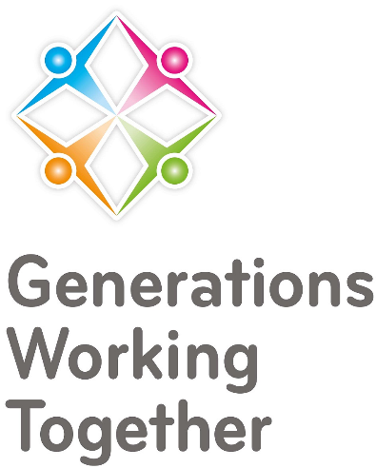

Glasgow and East Dunbartonshire Network Event – 15/06/2023

Agenda:
- Introductions (15-20 minutes)
- Workshop Exercise* (see overleaf) (30-40 minutes)
- Break/Networking (light refreshments) (20 minutes)
- Local Work and Projects (20-30 minute)
- GWT Updates (5-10 minutes)

*How do we support Scotland to become an Intergenerational Nation
One of GWT’s strategic aims for 2020-25 is to commence on a journey of enabling Scotland to become an intergenerational nation. GWT continues to develop the local and thematic networks and events, has grown social media communication and created and delivered a wider variety of intergenerational training opportunities. However, that said we would like to know from you, what you feel GWT and our membership could be doing to make this dream a reality. What does an intergenerational nation look like and how do we get there? This meeting will explore the practicalities and policy-influencing opportunities that are required, and will identify some of the potential barriers or challenges which may prevent us in achieving our goals.
Learning outcomes: After the network meeting, members will have a better understanding of what an intergenerational Nation could look like and how we together, can connect and help support this to happen.

We want to collect ideas about what Scotland needs, in order to become an intergenerational nation. We will explore the following:
- What will an IG Nation look like?
- How do we get there?
- What can GWT do to get us there?
- What can the membership do?

